Title of the Project: Automatic Gate Opener

**Group Information**

| **Sno** | **PRN** | **Name** |
| --- | --- | --- |
| **1** | **23070123065** | **Soham Jade** |
| **2** | **23070123061** | **Hussain Tayyebi** |
| **3** | **23070123039** | **Om Bhombe** |
| **4** | **23070123034** | **Ayush Shambharkar** |

# 1. Working of Project

## Project: Arduino Automatic Gate Opener

This project uses an Arduino to create a model automatic gate. An ultrasonic sensor detects an approaching object and signals a servo motor to open the gate arm, closing it again once the object moves away.

## How It Works

1. Sense: The HC-SR04 ultrasonic sensor constantly measures the distance to the nearest object.
2. Decide: The Arduino checks if the measured distance is less than a set threshold (e.g., 10 cm).
3. Act: If the threshold is crossed, the servo motor rotates to open the gate. Otherwise, it moves to the closed position.

## Tech Stack & Tools

* Hardware: Arduino Uno, HC-SR04 Ultrasonic Sensor, SG90 Servo Motor.
* Software: Arduino IDE, using C++ with the standard Servo.h library.

## Execution and Output

* Physical Output: The servo arm (gate) moves up when an object is close and moves down when the object is gone.
* Serial Output: The Arduino IDE's Serial Monitor displays a live feed of the distance measurements for monitoring and debugging.

## How to Run

1. Assemble Circuit: Connect the sensor and servo to the correct Arduino pins as defined in the code (Pins 11, 12, 13).
2. Upload Code: Open the code in the Arduino IDE, select your board and port, and click "Upload".
3. Test: Power the Arduino and move your hand toward the sensor to test the gate's operation.

## Execution Screenshots

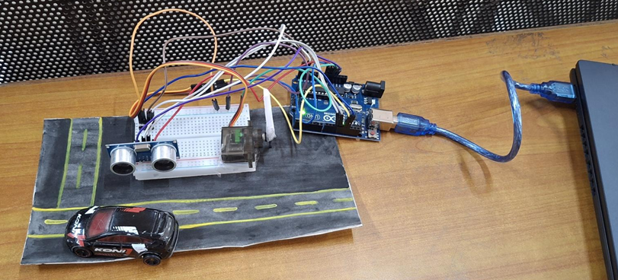

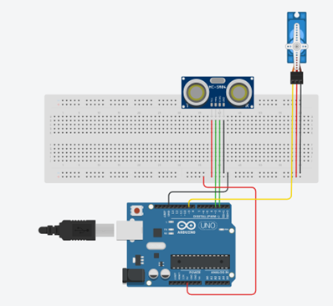

# 2. Innovation / Novelty / Contribution

## Unique Feature or Enhancement:

Enhance the gate opener by adding **red and green LEDs** as status indicators. The green light can signal when the gate is open, and the red light can signal when it's closed, providing clear visual feedback.

* **Student’s Individual Contribution**: Each Students Contribution Link
* **Table Format** (recommended for clarity):

| **Student Name** | **Role/Contribution** | **GitHub Profile** | **Key Commits / Pull Requests** |
| --- | --- | --- | --- |
| Hussain Tayyebi | Frontend Design, README | <https://github.com/Hussain1402> | <https://github.com/SohamJade/Automatic-Gate-opener/commits?author=Hussain1402> |
| Soham Jade | Shell Scripts, Automation | <https://github.com/SohamJade> | <https://github.com/SohamJade/Automatic-Gate-opener/commits?author=SohamJade> |
| Om Bhombe | Testing, | <https://github.com/ombhombe2344> | <https://github.com/SohamJade/Automatic-Gate-opener/commits?author=ombhombe2344> |
| Ayush Shambharkar | Bug Fixes | <https://github.com/Ayush-Shambharkar7> | <https://github.com/SohamJade/Automatic-Gate-opener/commits?author=Ayush-Shambharkar7> |

## Challenges Faced and Solved:

## A common challenge is the sensor providing **false readings**, causing the gate to open randomly. This is solved with a **software filter** that requires several consecutive "close" readings before opening the gate, which ignores single errors and improves reliability.

# 

# 

# 

# 3. Timely Submission

* **Progress**:

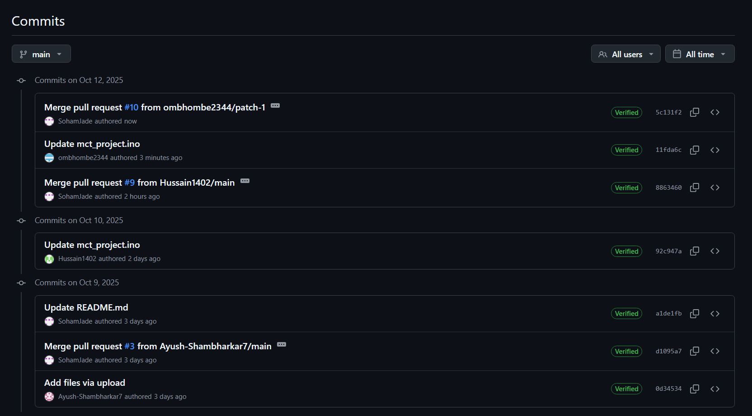

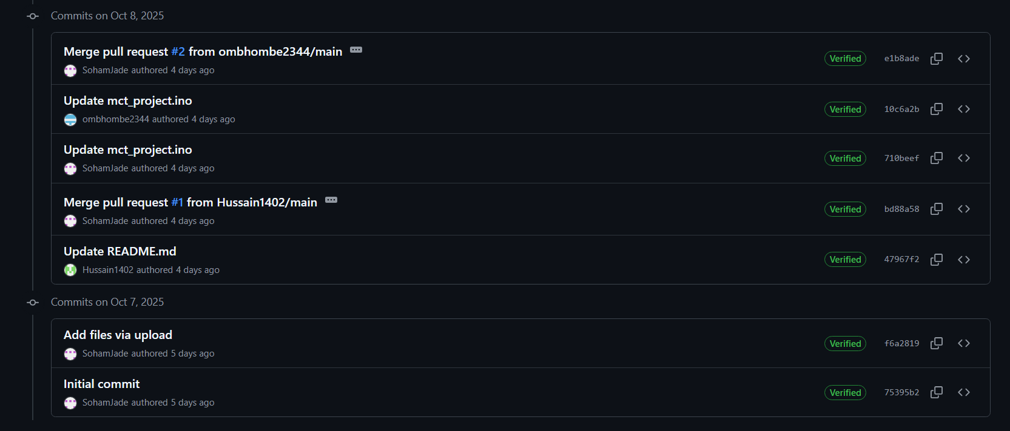

# 4. Pushing the Project to GitHub

* **GitHub Repository Link**: <https://github.com/SohamJade/Automatic-Gate-opener>
* **README File**: It contains all the necessary information related to the project repository which explains the objective and working of the project. It helps users understand the reason and operation of the given project.